IB Psychology: Topic Cognitive Processing

Content Schema Theory Study (Brewer & Treyins, 1981)
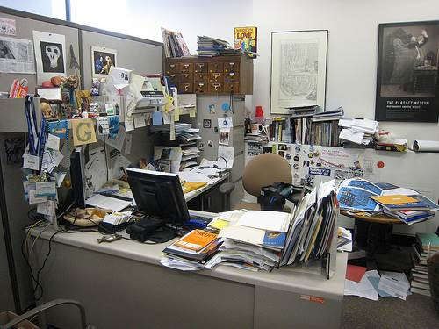
Aim: Brewer and Treyens wanted to study the role of schema in the encoding and retrieval of memory.
To do so, they carried out an experiment to see how well people could recall what was in an office. The sample was made up of 86 university psychology students. Participants were seated in a room that was made to look like an office. The room consisted of objects that were typical of offices (they fit the office schema): a typewriter, paper and a coffee pot. There was also a table with tools and electronics. There were shelves along one wall and the other walls were decorated with posters and a calendar. There were some items in the room that one would not typically find in an office - for example, a skull or a toy top. Finally, there were items that were omitted (left out of the room) - such as books.
Procedure: Each participant was asked to wait in the professor's office while the researcher "checked to make sure that the previous participant had completed the experiment." The participant did not realize that the study had already begun. The participants were asked to have a seat. All of the chairs except for one had objects on them. In this way, it was guaranteed that all participants would have the same vantage point in the office. The researcher left the room and said that he would return shortly.
After 35 seconds, the participants were called into another room and then asked what they remembered from the office. When they finished the experiment, they were given a questionnaire. The important question was "Did you think that you would be asked to remember the objects in the room?" 93% said "no."
The participants were randomly allocated to one of three conditions.
[This means how they were put into the 3 groups was not pre-determined. To randomly allocate means that names go into a hat, for example, and the first name is group 1, the second name is group 2, and the third name is group3, and so on. All participants in the study have equal chance of being allocated to each condition]
The recall condition: Participants were asked to write down a description of as many objects as they could remember from the office (free recall). They were also asked to state the location, shape, size and colour of the objects. They were asked to "Write your description as if you were describing the room for someone who had never seen it." After this, they were given a verbal recognition test in which they were given a booklet containing a list of objects. They were asked to rate each item for how sure they were that the object was in the room. "1" meant that they were sure it was not in the room; "6" meant that they were absolutely sure it was in the room. The questionnaire consisted of 131 objects: 61 were in the room; 70 were not.
The drawing condition: In this condition, participants were given an outline of the room and asked to draw in the objects they could remember. (a type of free recall)
The verbal recognition condition: In this condition, the participants were read a list of objects and simply asked whether they were in the room or not.
Findings:
Researchers found that when the participants were asked to recall either by writing a paragraph or by drawing, they were more likely to remember items in the office that were congruent with their schema of an office - that is, the "expected items" were more often recalled. The items that were incongruent with their schema of an office - e.g. the skull, a piece of bark or the screwdriver - were not often recalled. When asked to select items on the list, they were more likely to identify the incongruent items; for example, they didn't remember the skull when doing the free recall but gave it a 6 on the verbal recognition task. However, they also had a higher rate of identifying objects which were schema congruent but which were actually not in the room.
In both the drawing and the recall condition, they also tended to change the nature of the objects to match their schema. For example, the pad of yellow paper that was on a chair was remembered as being on the desk. The trapezoidal work table was recalled as square.

Critical Thinking practice:
Strength: method/lab experiment

Strength data collection:

Strength controlled variables

Thoughts on sample?

Any other CT comment:

